New Jersey Polygon Algo:

Usage Description: This feature is unlike the others. It will contain 6 user-controlled gauge meters. Something like this:

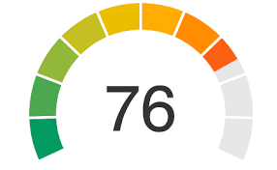

These will be located in the polygon data popups for the State of New Jersey in the location of the red lines in the below picture.

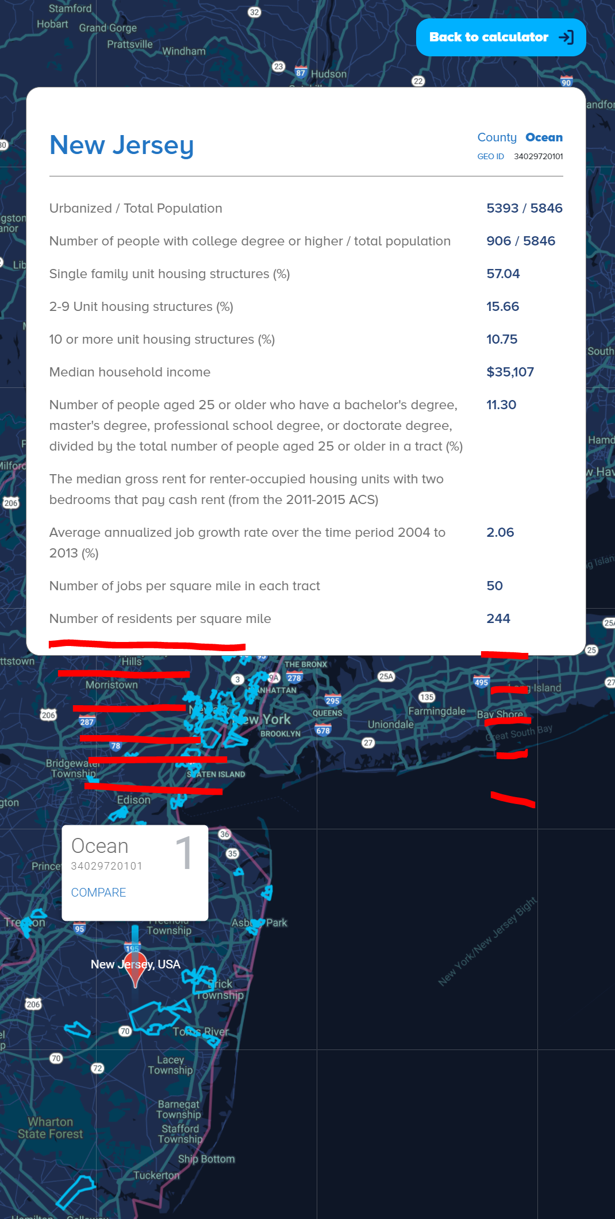

The text of the left column will be the values in cells B1:G1 in the embedded spreadsheet below.

The last row column 1 will say: Personalized Score. The last row column 2 will show the personalized score for that oz. Please not the polygon’s county value is needed to map values to polygons.



The table in cells A7:G23: will be stored in a table in MongoDb. As a user changes their dials and clicks the button “calculate” (in green in the above screenshot), polygons with Final Personalized Scores in the top quartile are outlined with hex color: #F0DC82.

Gauge Values will be saved to user accounts to that personalized scores are auto computed.

The embedded excel file show how the calculations are to be done.